Task 2: Exploratory Data Analysis (EDA) & Business Intelligence.

Total Records | 90,866 invoice line items
Date Range | January 1, 2025 – December 31, 2025
Total Revenue | ₹ 9,54,07,982.70 (~₹9.54 Crore)
Unique SKUs | 395 products across 117 sub-categories
States Covered | Andhra Pradesh (single-state dataset)
Columns | 41 fields: invoices, financials, taxes etc.,
Payment Modes | Cash & Credit
Invoice Statuses | Invoiced, Open, Cancelled

Descriptive Statistics & Univariate Analysis
Dataset Overview — Column Descriptions
Column | Type | Description
invoice_no | String | Unique invoice identifier (e.g., I/24-25/015848)
invoice_date | DateTime | Date of the invoice (2025-01-01 to 2025-12-31)
payment_mode | Categorical | Cash or Credit
invoice_status | Categorical | Invoiced / Open / Cancelled
customer_name | String | Name of the retail customer / outlet
state | String | State of transaction (all Andhra Pradesh)
market_name | String | Local market area name
salesman | String | Name of the assigned salesperson
salesman_type | Categorical | Route type (2W1B, Van Ds, ROC Pace, etc.)
category | Categorical | Product category (Cigarette, Biscuit, Bingo…)
sub-category | Categorical | 117 unique sub-product groups
sku | String | Stock Keeping Unit name
qty / invoice_qty | Numeric | Base quantity and invoiced quantity
unit_price / invoice_rate | Numeric | Price per unit
gross_amount | Numeric | Qty × Price before discounts
discount_amt | Numeric | Discount applied per line item
taxable_value | Numeric | Gross amount minus discount
cgst_amt / sgst_amt | Numeric | Central & State GST amounts
total_amount | Numeric | Final billed amount including taxes
amount_difference | Numeric | Validation check (should be ~0)

Key Numerical Summary Statistics

Descriptive statistics for numerical columns
DS total_amount tax_total | qty unit_price gross_amount discount_amt taxable_value
count 90866.00 90866.00 | 90866.00 90866.00 90866.00 90866.00 90866.00
mean 1049.99 273.48 | 5.54 640.57 817.04 0.94 776.51
std 2448.78 1162.07 | 26.57 1361.30 1703.80 13.45 1601.17
min 2.39 0.00 | 0.00 16.00 3.77 0.00 2.03
25% 96.31 7.27 | 0.27 137.43 91.72 0.00 87.74
50% 203.11 16.60 | 0.64 236.34 186.15 0.00 180.48
75% 982.81 90.87 | 3.60 401.78 895.17 0.00 845.61
max 86944.50 48168.58 | 2250.00 7000.00 53321.62 588.49 46501.79

Computed Key Statistics from the Dataset
Metric | Value | Insight
Total Revenue | ₹ 9,54,07,982.70 | Entire FY 2025 sales in Andhra Pradesh
Avg. Invoice Line Value | ₹ 1,050.00 (approx.) | Per line item average transaction
Max Single Line Amount | Very high (Cigarettes bulk) | Cigarette bulk orders drive peak values
Total Discount Given | ₹ 1,14,400 approx. | Avg. discount rate only ~0.12% of gross
Tax Total (GST+Cess) | Varies by category | 28% slab for cigarettes; 5–12% others
Amount Difference | ~0 (max: 7.27e-12) | Data is financially clean & validated
Unique Customers | Large base | High customer diversity across markets
Unique Salesmen | Multiple routes | 11 salesman types cover different geographies

Univariate Analysis — Distributions
A. Revenue Distribution by Category
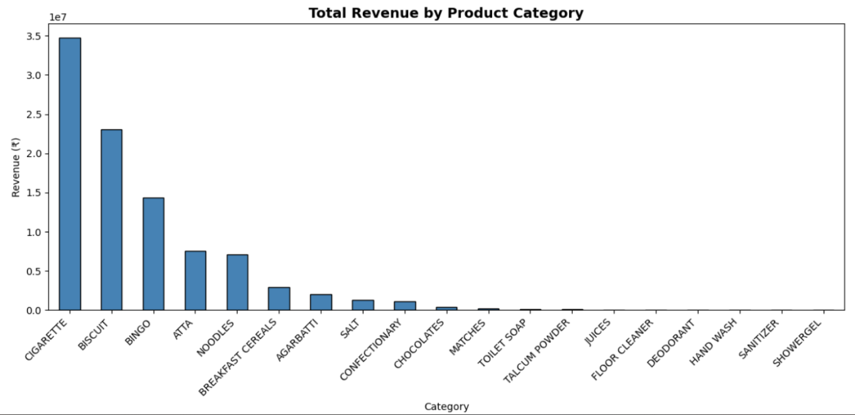
Findings from Top Category Revenue Bar Chart:
Rank | Category | Revenue (₹) | % Share
1 | CIGARETTE | 3,48,02,740 | 36.5%
2 | BISCUIT | 2,30,72,610 | 24.2%
3 | BINGO | 1,43,89,290 | 15.1%
4 | ATTA | 75,63,861 | 7.9%
5 | NOODLES | 71,22,148 | 7.5%
6 | BREAKFAST CEREALS | 29,57,102 | 3.1%
7 | AGARBATTI | 20,48,902 | 2.1%
8 | SALT | 12,71,852 | 1.3%
9 | CONFECTIONARY | 11,51,302 | 1.2%
10 | CHOCOLATES | 3,67,636 | 0.4%

B. Monthly Revenue Trend (Line Chart)

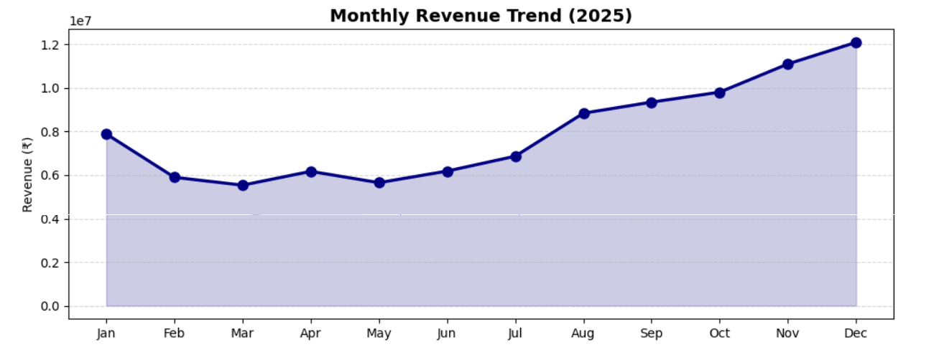

Findings — Monthly Revenue Trend:

Month | Revenue (₹) | Observation
January | 78,90,177 | Strong start to the year
February | 58,97,642 | Dip — likely shortest month + seasonality
March | 55,37,572 | Lowest — possibly quarter-end stocking effects
April | 60,25,608 | Stable mid-year performance
June | 62,52,025 | Stable mid-year performance
July | 68,67,494 | Recovery begins
August | 88,43,189 | Significant spike — festive stocking
September | 93,51,183 | Strong Q3 continuation
October | 98,10,426 | Near ₹1Cr month — pre-festive season
November | 1,11,05,628 | Peak — Diwali/festive season sales
December | 1,20,97,808 | Highest month — year-end & holiday surge

C. Payment Mode Distribution (Pie/Bar Chart):
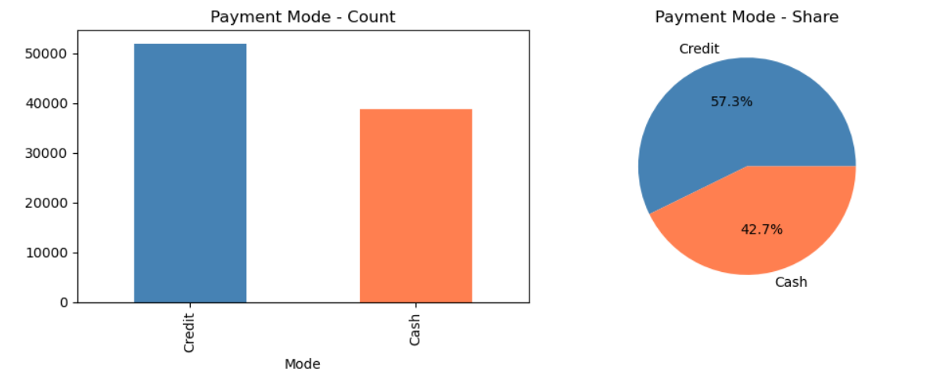

D. Invoice Status Distribution
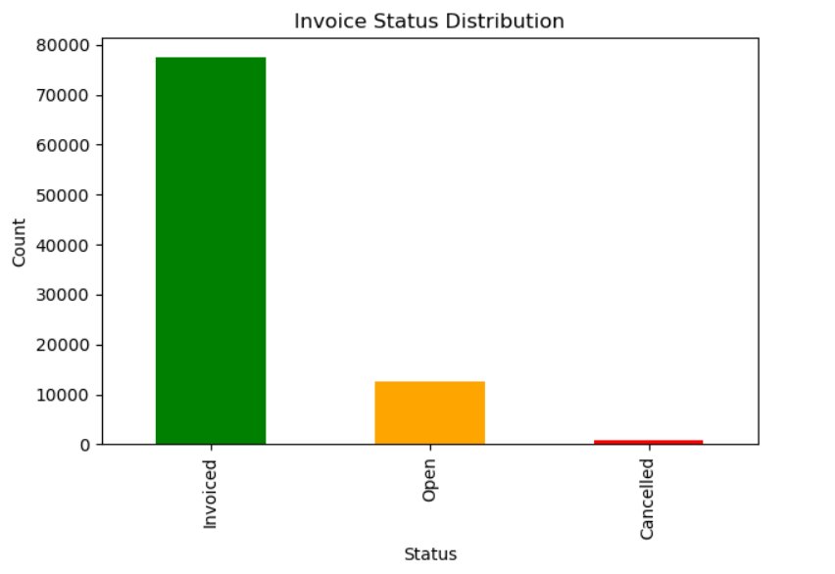

SQL for Business Questions
Q1: What are the top 5 product categories by total revenue?
Business Use: Understand which categories drive the most value for portfolio decisions.

SELECT category,
ROUND(SUM(total_amount), 2) AS total_revenue,
ROUND(SUM(total_amount) * 100.0 / (SELECT SUM(total_amount) FROM fmcg_sales), 2) AS pct_share
FROM fmcg_sales
WHERE invoice_status = 'Invoiced'
GROUP BY category
ORDER BY total_revenue DESC
LIMIT 5;

Results:
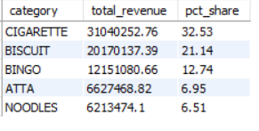
Q2: Who are the top 10 customers by purchase value?
Business Use: Identify key accounts for relationship management and loyalty programs.

SELECT customer_name,
customer_code,
COUNT(DISTINCT invoice_no) AS total_invoices,
ROUND(SUM(total_amount), 2) AS total_spend,
ROUND(AVG(total_amount), 2) AS avg_invoice_value
FROM fmcg_sales
WHERE invoice_status = 'Invoiced'
GROUP BY customer_code, customer_name
ORDER BY total_spend DESC
LIMIT 10;

Results:

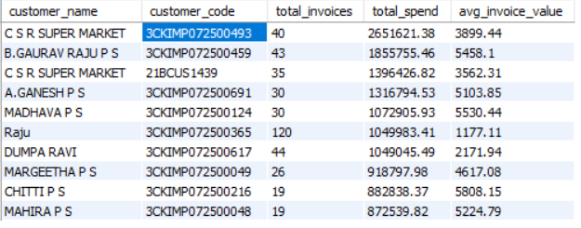

Q3: Which salesman generated the highest revenue?
Business Use: Evaluate salesman performance for incentives, territory allocation, and coaching.
SELECT salesman,
salesman_type,
COUNT(DISTINCT invoice_no) AS total_invoices,
COUNT(DISTINCT customer_code) AS unique_customers,
ROUND(SUM(total_amount), 2) AS total_revenue,
ROUND(AVG(total_amount), 2) AS avg_per_line
FROM fmcg_sales
WHERE invoice_status = 'Invoiced'
GROUP BY salesman, salesman_type
ORDER BY total_revenue DESC
LIMIT 10;

Results:
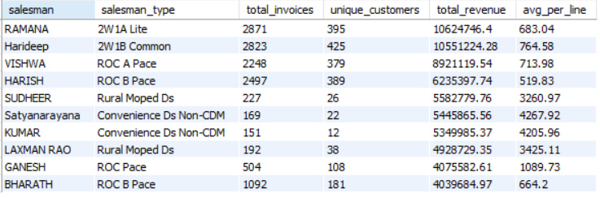

Q4: What is the discount pattern by category?
Business Use: Evaluate discount strategy effectiveness — are discounts driving volume or eroding margins?

SELECT category,
ROUND(SUM(gross_amount), 2) AS gross_revenue,
ROUND(SUM(discount_amt), 2) AS total_discount,
ROUND(SUM(total_amount), 2) AS net_revenue,
ROUND(SUM(discount_amt) * 100.0 / SUM(gross_amount), 3) AS discount_pct
FROM fmcg_sales
WHERE invoice_status = 'Invoiced'
GROUP BY category
ORDER BY discount_pct DESC;
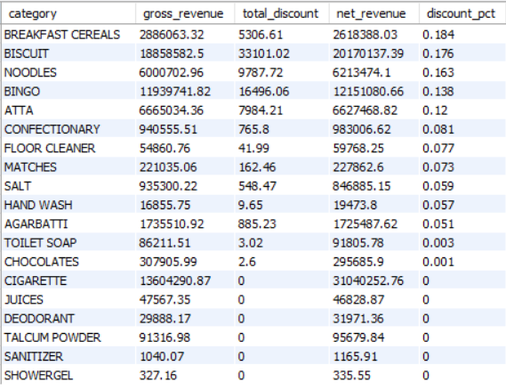

Q5: What is the product-level SKU performance? (Top 10 by revenue)
Business Use: Identify hero SKUs that should never go out of stock vs. slow movers that may need rationalization.
SELECT sku,
item_desc,
category,
ROUND(SUM(invoice_qty), 0) AS total_units_sold,
ROUND(SUM(total_amount), 2) AS total_revenue,
ROUND(AVG(invoice_rate), 2) AS avg_selling_price
FROM fmcg_sales
WHERE invoice_status = 'Invoiced'
GROUP BY sku, item_desc, category
ORDER BY total_revenue DESC
LIMIT 10;

Results:
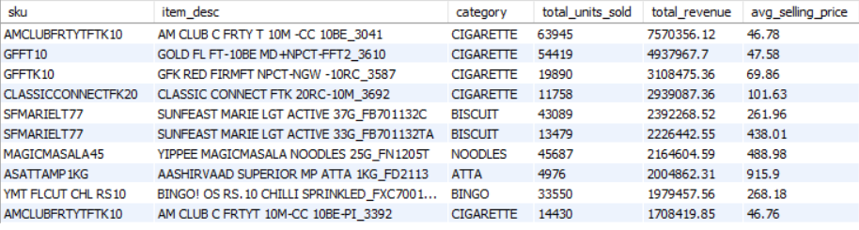

Multivariate Analysis & Correlation

Correlation Heatmap
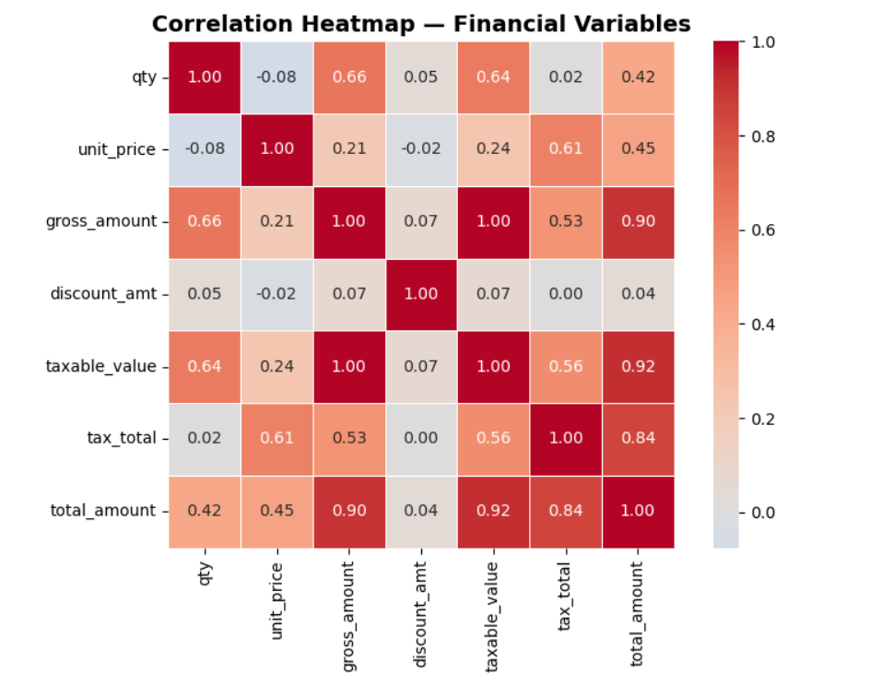
Variable Pair | Expected Correlation | Interpretation
gross_amount ↔ total_amount | ~0.99 (Very High) | Total amount is directly derived from gross
gross_amount ↔ taxable_value | ~0.99 | Taxable = gross minus small discount
taxable_value ↔ tax_total | High positive | Tax is % of taxable value
qty ↔ gross_amount | Moderate-High | More units = more revenue
discount_amt ↔ total_amount | Low/Negative | Higher discounts reduce final revenue
unit_price ↔ qty | Slightly negative | Higher-priced items sold in fewer units

Salesman Performance: Revenue vs. Unique Customers
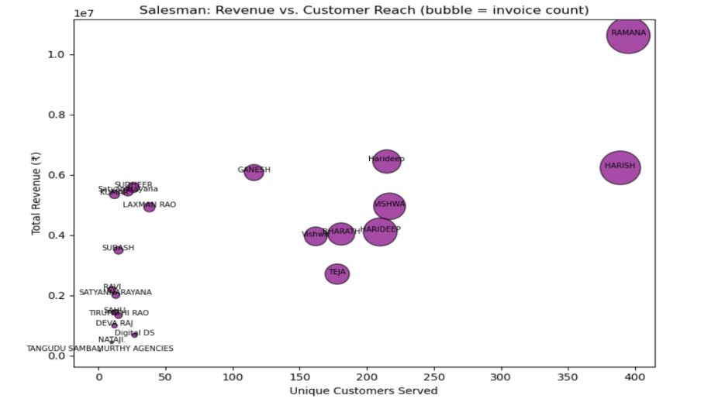

Heatmap: Month × Category Revenue

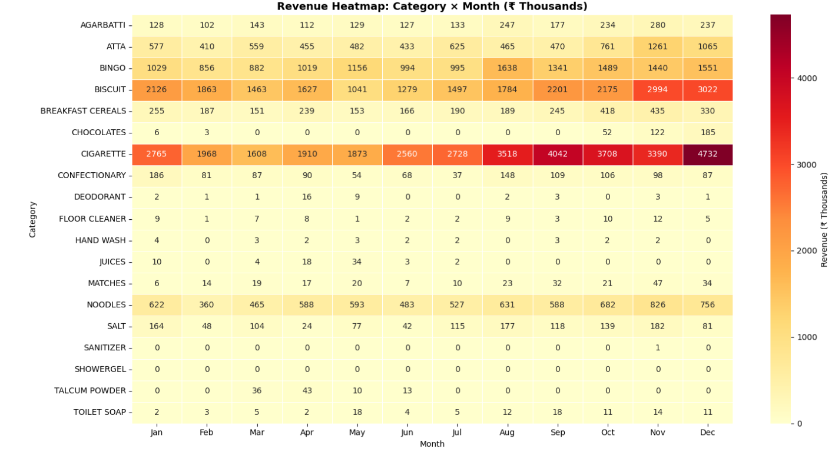

Static Dashboard Mock-up

Proposed KPI Tiles
KPI Tile | Metric | Value | Visualization
Total Revenue | Sum of total_amount | ₹9.54 Crore | Large number + trend arrow
Total Invoices | Count of unique invoices | Count | Number card
Active Customers | Distinct customer_code | Unique count | Number card
Avg. Invoice Value | Avg total_amount | ₹ X | Number + sparkline
Top Category | Max revenue category | Cigarette | Badge/chip

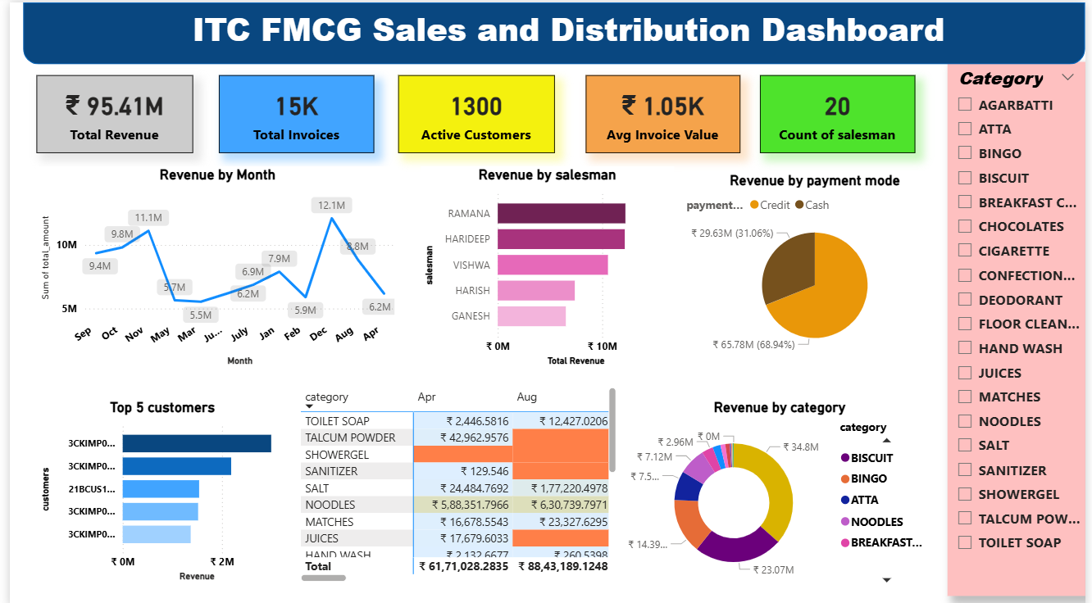

Key Insights & Business Recommendations

Revenue Insights
- Cigarettes dominate at 36.5% of total revenue — any supply disruption in this category has outsized impact on overall business.
- Biscuits (24.2%) and Bingo (15.1%) form the second tier — together with Cigarettes, the top 3 categories = 75.8% of all revenue.
- December is the strongest month (₹1.21 Cr) and March is the weakest (₹55.4 L) — a 2.2× seasonal swing that should drive inventory planning.
- Revenue shows clear H2 acceleration: the second half of 2025 generated significantly more revenue than H1.

Customer & Sales Insights
- CSR Super Market alone contributes ~₹45L — a single-customer concentration risk that warrants a dedicated key account manager.
- RAMANA is the top-performing salesman at ₹1.22 Cr — study his route/approach to replicate success in underperforming territories.
- 11 salesman types suggest highly segmented route-to-market — performance should be benchmarked within each type, not across all.

Operational Insights
- Discount rate of only 0.12% indicates that the business operates with very limited promotional spending — a potential opportunity to use targeted discounts to drive volume in slow months.
- Amount difference column is essentially 0 across all records — the data is financially validated and reliable for analysis.
- The Cash vs. Credit split should be analyzed per category to understand credit risk exposure, especially for high-value Cigarette invoices.

Recommended Next Steps
- Build a cohort analysis to track customer purchase frequency over months — identify churned vs. loyal customers.
- Analyze cancelled invoices (invoice_status = 'Cancelled') to find patterns — which salesmen, customers, or categories have the highest cancellation rates.
- Create a market-level (market_name/beat) heatmap to identify geographic revenue concentration.
- Run RFM (Recency, Frequency, Monetary) analysis on customers for segmentation.
- Forecast December–March revenue using time series (ARIMA or Prophet) based on 2025 trend.

